LAPORAN PRAKTIKUM
Pertemuan : 9 dan 10
MK: Metode Statistika II
Materi: ANOVA, Uji Perbandingan Proporsi, Uji Chi Kuadrat

- Bagaimana membentuk model regresi
- Bagaimana kita memodelkan regresi
- Menggunakan tabel F dan T tergantung hubungan parsial atau non parsial
- ANOVA untuk Melihat hubungan simultan (keseluruhan) dan parsial (sebagian)

Sintaks:

#UJI ANOVA

# Comparing means with ANOVA

#Load data
#each group in separate variable
x1<- rnorm(30, mean=40, sd=8)
x2<-rnorm(30, mean=41, sd=8)
x3<- rnorm(30, mean=45, sd=8)
x4<-rnorm(30, mean=45, sd=8)

#Formula result is F(3,116) = 3.24, p= .025
boxplot(x1,x2,x3,x4) #quick graphical check

#Combine vector into a single data frame
xdf<-data.frame(cbind(x1,x2,x3,x4))
summary(xdf)

#stack data to get one column with outcome and second columns with group
xs <-stack(xdf)
#Conduct one-way ANOVA
annova1 <- aov(values~ind, data = xs)
annova1
summary(annova1)

#Post-hoc comparisons
TukeyHSD(annova1)
?pairwise.t.test #other post-hoc test
?p.adjust #spesific method

rm(list=ls()) #clean up

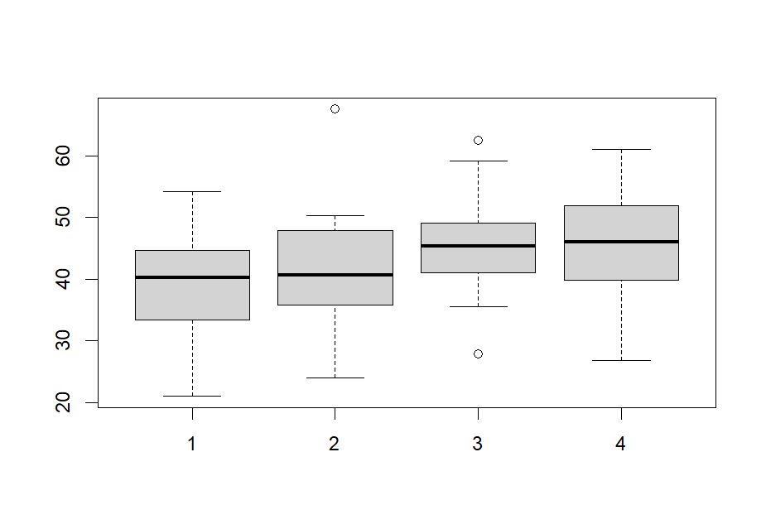

Output:
> #UJI ANOVA
>
> # Comparing means with ANOVA
>
> #Load data
> #each group in separate variable
> x1<- rnorm(30, mean=40, sd=8)
> x2<-rnorm(30, mean=41, sd=8)
> x3<- rnorm(30, mean=45, sd=8)
> x4<-rnorm(30, mean=45, sd=8)
>
> #Formula result is F(3,116) = 3.24, p= .025
> boxplot(x1,x2,x3,x4) #quick graphical check
>
> #Combine vector into a single data frame
> xdf<-data.frame(cbind(x1,x2,x3,x4))
> summary(xdf)
x1 x2 x3 x4
Min. :18.41 Min. :29.27 Min. :27.38 Min. :29.03
1st Qu.:33.29 1st Qu.:38.39 1st Qu.:40.15 1st Qu.:34.91
Median :42.03 Median :40.38 Median :47.82 Median :43.78
Mean :40.16 Mean :42.22 Mean :45.68 Mean :43.69
3rd Qu.:44.95 3rd Qu.:45.52 3rd Qu.:52.22 3rd Qu.:50.44
Max. :61.22 Max. :58.64 Max. :57.75 Max. :59.84
>
>
> #stack data to get one column with outcome and second columns with group
> xs <-stack(xdf)
> #Conduct one-way ANOVA
> annova1 <- aov(values~ind, data = xs)
> annova1
Call:
aov(formula = values ~ ind, data = xs)

Terms:
ind Residuals
Sum of Squares 489.838 7491.388
Deg. of Freedom 3 116

Residual standard error: 8.036226
Estimated effects may be unbalanced
> summary(annova1)
Df Sum Sq Mean Sq F value Pr(>F)
ind 3 490 163.28 2.528 0.0608 .
Residuals 116 7491 64.58
---
Signif. codes: 0 ‘***’ 0.001 ‘**’ 0.01 ‘*’ 0.05 ‘.’ 0.1 ‘ ’ 1
>
> #Post-hoc comparisons
> TukeyHSD(annova1)
Tukey multiple comparisons of means
95% family-wise confidence level

Fit: aov(formula = values ~ ind, data = xs)

$ind
diff lwr upr p adj
x2-x1 2.061818 -3.3468679 7.470503 0.7533143
x3-x1 5.522251 0.1135657 10.930937 0.0434598
x4-x1 3.530868 -1.8778176 8.939554 0.3275053
x3-x2 3.460434 -1.9482522 8.869119 0.3454302
x4-x2 1.469050 -3.9396354 6.877736 0.8937499
x4-x3 -1.991383 -7.4000689 3.417302 0.7724921

> ?pairwise.t.test #other post-hoc test
> ?p.adjust #spesific method
>
> rm(list=ls()) #clean up

>

Interpretasi:
Rnorm adalah random normal number, angka acak yang berdistibusi normal sebanyak 30 angka dengan rata-rata 40, 41, 45, dan 45 dengan simpangan baku 8.

$H_{o}$ ditolak karena < $H_{1}$ ketika $F_{hitung}$ dibandingkan dengan $F_{tabel}$.

2. UJI HIPOTESIS PROPORSI
Sintaks:

#UJI PROPORSI (MEMANDINGKAN PROPORSI)

#Load Data
#Need two vectors
#One specifies the total number of people in each group
#this creates a vector with 5 100s in it, for 5 groups
#same as "number trials"
n5<-c(rep(100,5))

#another specifiers the number of people who are in category
#same as "number of success"
x5<-c(65,60,60,50,45)
prop.test(x5,n5)

#if there are only two groups, then gives a confidence
#interval for the difference between the groups;
#the difficult CI is .95 (taraf signifikansi 95%)
n2<-c(40,40) #number of trials
x2<-c(30,20) #number of success
prop.test(x2,n2, conf.level = .80) #taraf keyakinan 80%

rm(list = ls()) # Clean up

Output:
> #UJI PROPORSI (MEMANDINGKAN PROPORSI)
>
> #Load Data
> #Need two vectors
> #One specifies the total number of people in each group
> #this creates a vector with 5 100s in it, for 5 groups
> #same as "number trials"
> n5<-c(rep(100,5))
>
> #another specifiers the number of people who are in category
> #same as "number of success"
> x5<-c(65,60,60,50,45)
> prop.test(x5,n5)

5-sample test for equality of proportions without continuity
correction

data: x5 out of n5
X-squared = 10.958, df = 4, p-value = 0.02704
alternative hypothesis: two.sided
sample estimates:
prop 1 prop 2 prop 3 prop 4 prop 5
0.65 0.60 0.60 0.50 0.45

>
> #if there are only two groups, then gives a confidence
> #interval for the difference between the groups;
> #the difficult CI is .95 (taraf signifikansi 95%)
> n2<-c(40,40) #number of trials
> x2<-c(30,20) #number of success
> prop.test(x2,n2, conf.level = .80) #taraf keyakinan 80%

2-sample test for equality of proportions with continuity
correction

data: x2 out of n2
X-squared = 4.32, df = 1, p-value = 0.03767
alternative hypothesis: two.sided
80 percent confidence interval:
0.09097213 0.40902787
sample estimates:
prop 1 prop 2
0.75 0.50

>
> rm(list = ls()) # Clean up

>

Interpretasi: Dari hasil uji perbandingan proporsi yang telah dilakukan, dapat diambil beberapa kesimpulan:

### Uji Pertama (5 Sampel):
- **Tujuan Uji:** Membandingkan proporsi di antara lima kelompok.
- **Hasil Uji Chi-Square:** Chi-Square = 10.958, df = 4, p-value = 0.02704.
- **Kesimpulan:** Terdapat bukti statistik yang cukup untuk menyimpulkan bahwa proporsi di antara kelompok-kelompok tersebut berbeda secara signifikan. P-value yang rendah (0.02704) menunjukkan bahwa terdapat perbedaan yang signifikan dalam proporsi di antara kelompok-kelompok tersebut.

### Uji Kedua (2 Sampel):
- **Tujuan Uji:** Membandingkan proporsi di antara dua kelompok dengan tingkat kepercayaan 80%.
- **Hasil Uji Chi-Square:** Chi-Square = 4.32, df = 1, p-value = 0.03767.
- **Intervar Confidence (CI) 80%:** 0.09097213 hingga 0.40902787.
- **Kesimpulan:** Terdapat bukti statistik yang cukup pada tingkat kepercayaan 80% untuk menyatakan bahwa proporsi di antara kedua kelompok tersebut berbeda secara signifikan. P-value yang rendah (0.03767) menunjukkan perbedaan yang signifikan dalam proporsi di antara kedua kelompok tersebut.

### Kesimpulan Umum:
- Dari kedua uji tersebut, dapat disimpulkan bahwa terdapat perbedaan yang signifikan dalam proporsi di antara kelompok-kelompok yang diuji.
- Jika terdapat dua kelompok, perbedaan tersebut juga dapat diukur dan dijelaskan dengan tingkat kepercayaan tertentu menggunakan interval kepercayaan (CI). Dalam contoh ini, digunakan CI 80%.

### Catatan:
- P-value yang lebih rendah dari tingkat signifikansi yang ditentukan (biasanya 0.05) menunjukkan adanya perbedaan yang signifikan.
- Interval kepercayaan yang tidak mencakup nilai nol menunjukkan perbedaan yang signifikan antara proporsi kelompok-kelompok yang dibandingkan.

**Perlu dicatat:** Kesimpulan ini didasarkan pada asumsi-asumsi uji proporsi dan kualitas data yang digunakan dalam analisis. Selalu penting untuk mempertimbangkan konteks khusus dan menghindari generalisasi berlebihan tanpa mempertimbangkan konteks data dan tujuan analisis.

3. UJI CHI-SQUARE
Sintaks:

#Uji Chi Square

#Creating crosstabs for categorical variabels

#Load data
?Titanic
str(Titanic)
Titanic
ftable(Titanic) #makes "flat" table

#Convert tble to data frame with one row per observation
tdf<-as.data.frame(lapply(as.data.frame.table(Titanic), function(x)rep(x, as.data.frame.table(Titanic)$Freq))) [,-5]
tdf[1:5, ] #check first five rows of data

#Create contingency
ttab <-table(tdf$Class, tdf$Survived)
ttab

#Call also get cell row, and column %
#with rounding to get just 2 decimals places
#Multiplied by 100 to make %
round(prop.table(ttab, 1),2)*100 #row %
round(prop.table(ttab, 2), 2)*100 #column %
round(prop.table(ttab),2)*100 #cell %

#Chi-squared test
tchi<-chisq.test(ttab)
tchi

#Additional tables
tchi$observed # observed frequencies (same as ttab)
tchi$expected # Expected frequencies
tchi$residuals #Pearson#s residual
tchi$stdres #Standariezed residual

rm(list=ls()) #Clean up

Output:
> #Uji Chi Square
>
> #Creating crosstabs for categorical variabels
>
> #Load data
> ?Titanic
> str(Titanic)
'table' num [1:4, 1:2, 1:2, 1:2] 0 0 35 0 0 0 17 0 118 154 ...
- attr(*, "dimnames")=List of 4
..$ Class : chr [1:4] "1st" "2nd" "3rd" "Crew"
..$ Sex : chr [1:2] "Male" "Female"
..$ Age : chr [1:2] "Child" "Adult"
..$ Survived: chr [1:2] "No" "Yes"
> Titanic
, , Age = Child, Survived = No

Sex
Class Male Female
1st 0 0
2nd 0 0
3rd 35 17
Crew 0 0

, , Age = Adult, Survived = No

Sex
Class Male Female
1st 118 4
2nd 154 13
3rd 387 89
Crew 670 3

, , Age = Child, Survived = Yes

Sex
Class Male Female
1st 5 1
2nd 11 13
3rd 13 14
Crew 0 0

, , Age = Adult, Survived = Yes

Sex
Class Male Female
1st 57 140
2nd 14 80
3rd 75 76
Crew 192 20

> ftable(Titanic) #makes "flat" table
Survived No Yes
Class Sex Age
1st Male Child 0 5
Adult 118 57
Female Child 0 1
Adult 4 140
2nd Male Child 0 11
Adult 154 14
Female Child 0 13
Adult 13 80
3rd Male Child 35 13
Adult 387 75
Female Child 17 14
Adult 89 76
Crew Male Child 0 0
Adult 670 192
Female Child 0 0
Adult 3 20
>
>
> #Convert tble to data frame with one row per observation
> tdf<-as.data.frame(lapply(as.data.frame.table(Titanic), function(x)rep(x, as.data.frame.table(Titanic)$Freq))) [,-5]
> tdf[1:5, ] #check first five rows of data
Class Sex Age Survived
1 3rd Male Child No
2 3rd Male Child No
3 3rd Male Child No
4 3rd Male Child No
5 3rd Male Child No
>
> #Create contingency
> ttab <-table(tdf$Class, tdf$Survived)
> ttab

No Yes
1st 122 203
2nd 167 118
3rd 528 178
Crew 673 212
>
> #Call also get cell row, and column %
> #with rounding to get just 2 decimals places
> #Multiplied by 100 to make %
> round(prop.table(ttab, 1),2)*100 #row %

No Yes
1st 38 62
2nd 59 41
3rd 75 25
Crew 76 24
> round(prop.table(ttab, 2), 2)*100 #column %

No Yes
1st 8 29
2nd 11 17
3rd 35 25
Crew 45 30
> round(prop.table(ttab),2)*100 #cell %

No Yes
1st 6 9
2nd 8 5
3rd 24 8
Crew 31 10
>
> #Chi-squared test
> tchi<-chisq.test(ttab)
> tchi

Pearson's Chi-squared test

data: ttab
X-squared = 190.4, df = 3, p-value < 2.2e-16

>
> #Additional tables
> tchi$observed # observed frequencies (same as ttab)

No Yes
1st 122 203
2nd 167 118
3rd 528 178
Crew 673 212
> tchi$expected # Expected frequencies

No Yes
1st 220.0136 104.98637
2nd 192.9350 92.06497
3rd 477.9373 228.06270
Crew 599.1140 285.88596
> tchi$residuals #Pearson#s residual

No Yes
1st -6.607873 9.565772
2nd -1.867159 2.702959
3rd 2.289965 -3.315027
Crew 3.018611 -4.369840
> tchi$stdres #Standariezed residual

No Yes
1st -12.593038 12.593038
2nd -3.521022 3.521022
3rd 4.888701 -4.888701
Crew 6.868541 -6.868541
>
> rm(list=ls()) #Clean up

>

Interpretasi:
Hasil uji chi-square pada tabel kontingensi yang diberikan menunjukkan:

### Output Uji Chi-Square:
- **Statistik Chi-Square:** 190.4
- **Derajat Kebebasan (df):** 3
- **Nilai p (p-value):** < 2.2e-16 (sangat kecil)

### Kesimpulan:
1. **Nilai p yang sangat kecil (< 0.05):**
- Terdapat bukti statistik yang kuat untuk menolak hipotesis nol.
- Hipotesis nol dalam uji ini menyatakan bahwa tidak ada hubungan antara kategori "Class" dan "Survived".

2. **Interpretasi Hasil:**
- Terdapat perbedaan yang signifikan antara proporsi orang yang selamat dan tidak selamat di setiap kelas.
- Proporsi orang yang selamat dan tidak selamat berbeda secara signifikan antar kelas.
- Hubungan antara variabel "Class" dan "Survived" adalah signifikan secara statistik.

### Tabel Tambahan:
- **Tabel Frekuensi (Observed):**

| | No | Yes |
|----------|------|------|
| 1st | 122 | 203 |
| 2nd | 167 | 118 |
| 3rd | 528 | 178 |
| Crew | 673 | 212 |

- **Tabel Frekuensi (Expected):**

| | No | Yes |
|----------|----------|----------|
| 1st | 220.0136 | 104.9864 |
| 2nd | 192.935 | 92.065 |
| 3rd | 477.9373 | 228.0627 |
| Crew | 599.114 | 285.886 |

- **Tabel Residuals:**

| | No | Yes |
|----------|-------------|-------------|
| 1st | -6.607873 | 9.565772 |
| 2nd | -1.867159 | 2.702959 |
| 3rd | 2.289965 | -3.315027 |
| Crew | 3.018611 | -4.36984 |

- **Tabel Standardized Residuals:**

| | No | Yes |
|----------|------------|------------|
| 1st | -12.593038 | 12.593038 |
| 2nd | -3.521022 | 3.521022 |
| 3rd | 4.888701 | -4.888701 |
| Crew | 6.868541 | -6.868541 |

### Interpretasi Tambahan:
1. **Tabel Residuals dan Standardized Residuals:**
- Menunjukkan seberapa jauh nilai observed dari nilai expected.
- Nilai Residuals yang besar menunjukkan adanya perbedaan yang signifikan antara nilai observed dan expected.
- Standardized Residuals yang besar menunjukkan seberapa besar perbedaan tersebut dalam satuan standar.

2. **Perbandingan Frekuensi Observed dan Expected:**
- Frekuensi observed pada setiap sel dalam tabel kontingensi secara signifikan berbeda dari frekuensi yang diharapkan.

### Kesimpulan Akhir:
- Dengan nilai p yang sangat rendah, dapat disimpulkan bahwa ada hubungan yang signifikan antara variabel "Class" dan "Survived".
- Setiap kelas memiliki pengaruh yang signifikan terhadap kelangsungan hidup seseorang dalam insiden Titanic.

